SIMATS ENGINEERING
ASSESSMENT TOOL 3

COURSE NAME: Artificial Intelligence COURSE CODE: CSA17

COURSE OUTCOME COVERED

CO2: Experiment search and game-solving techniques such as Greedy Search, A*, CSP, Minimax, and Alpha-Beta pruning with heuristic functions for solving complex AI problems efficiently. (BL3)

Assessment Tool Weightage: 40%

Duration: 1 Hour QUESTIONS: 3 Total Marks:30

Annexure A

Dry Run Evaluation

Code of Conduct:

I M Mohan siva reddy(192573011) (Name / Reg No) certify that this submission is my original work and that I have adhered to the guidelines specified for this assessment.
I understand that any violation of academic integrity rules will result in disciplinary action.

Signature of the student: msvvreddy

Annexure A

Dry Run Evaluation

23: M Mohana Siva Vikasvanth Reddy | Register Number: 192573011
17 - Minimax Dry Run
Perform the Minimax algorithm on the displayed game tree.
Calculate the value of each MIN node, the MAX root value and the move selected by MAX.
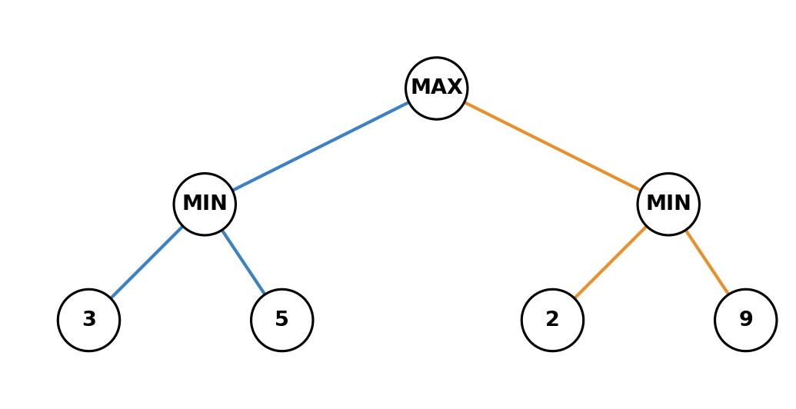
Node | Children Values | Value
1
2
3
4
5

- Question 18 - Minimax with Deeper Tree
Consider a MAX root with two MIN children. Each MIN child has two MAX children. The leaf values from left to right are: 3,5 | 2,9 | 4,6 | 1,7.
Perform a complete Minimax dry run and identify the optimal move.
Node | Children Values | Value
1
2
3
4
5
6
7

- Question 19 - Alpha-Beta Pruning
Evaluate the displayed game tree from left to right using Alpha-Beta pruning.
Show alpha and beta values, identify pruned nodes and determine the final minimax value.
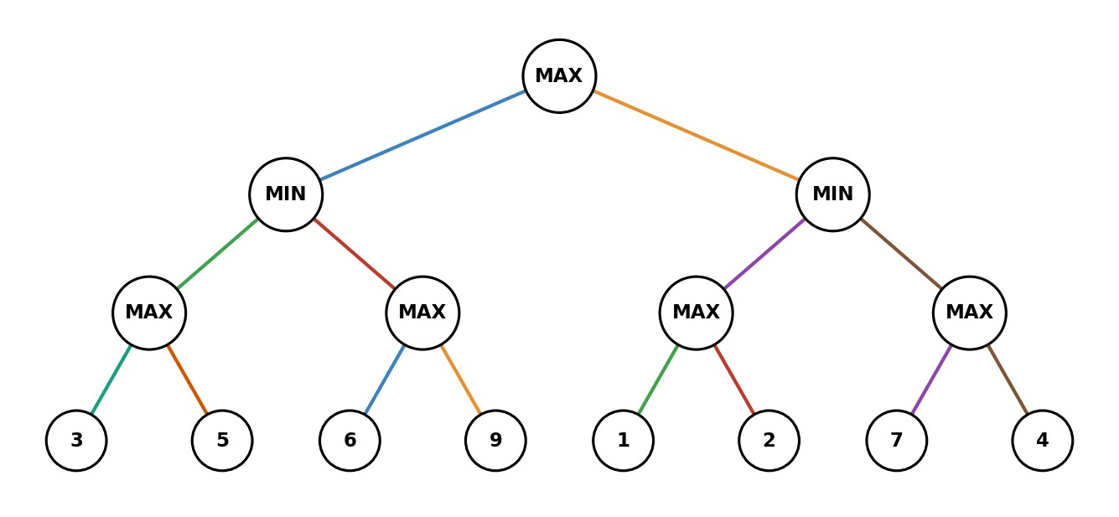
Node | alpha | beta | Action / Pruning
1
2
3
4
5

Q17. Minimax Dry Run
Rule: MIN selects the smaller value, and MAX selects the larger value.
Node | Children Values | Value
1 – MAX | 3, 2 | 3
2 – MIN | 3, 5 | 3
3 | — | 3
4 | — | 5
5 – MIN | 2, 9 | 2
Calculation:
- Left MIN = min(3, 5) = 3
- Right MIN = min(2, 9) = 2
- MAX root = max(3, 2) = 3
Final Answer:
MAX value = 3
Selected move = Left branch

Q18. Minimax with Deeper Tree
Leaf values:
3, 5 | 2, 9 | 4, 6 | 1, 7
Node | Children Values | Value
1 – MAX | 5, 6 | 6
2 – MIN | 5, 9 | 5
3 – MIN | 6, 7 | 6
4 – MAX | 3, 5 | 5
5 – MAX | 2, 9 | 9
6 – MAX | 4, 6 | 6
7 – MAX | 1, 7 | 7
Calculation
- MAX node 4 = max(3,5) = 5
- MAX node 5 = max(2,9) = 9
- Left MIN = min(5,9) = 5
- MAX node 6 = max(4,6) = 6
- MAX node 7 = max(1,7) = 7
- Right MIN = min(6,7) = 6
- Root MAX = max(5,6) = 6
Final Answer:
MAX value = 6
Optimal move = Right branch

Q19. Alpha-Beta Pruning
The tree is evaluated from left to right.
Step-by-step
Left MIN subtree:
- First MAX: max(3,9) = 9
- Second MAX: max(6,9) = 9
- Left MIN = min(9,9) = 9
- Root α = 9
Right MIN subtree:
- First MAX: max(1,1) = 1
- Right MIN β = 1
- Since β ≤ α → 1 ≤ 9, the second MAX node is pruned.
- Therefore, leaves 7 and 4 are not evaluated.
Node | Alpha (α) | Beta (β) | Action / Pruning
1 – Root MAX | 9 | ∞ | Continue
2 – Left MIN | -∞ | 9 | Continue
3 – Left MAX | 9 | ∞ | Expanded
4 – Right MAX of left MIN | 9 | 9 | Expanded
5 – Right MIN | 9 | 1 | Prune remaining MAX (7,4)

Final Result
Left MIN = 9
Right MIN = 1
Root MAX = max(9,1) = 9
Final Minimax value = 9
Pruned nodes = 7 and 4
MAX selects the left branch

